HAFIZ.M FAWAD LAB 03 FA17-BECE-0018

CODE:
user@user-OptiPlex-7040:~$ cd Documents
user@user-OptiPlex-7040:~/Documents$ ls
OSLAB
user@user-OptiPlex-7040:~/Documents$ cd OSLAB
user@user-OptiPlex-7040:~/Documents/OSLAB$ ls
myfile
user@user-OptiPlex-7040:~/Documents/OSLAB$ sudo nano myfile
[sudo] password for user:
user@user-OptiPlex-7040:~/Documents/OSLAB$ ls
myfile
user@user-OptiPlex-7040:~/Documents/OSLAB$ gedit myfile

user@user-OptiPlex-7040:~/Documents/OSLAB$ chmod -w myfile
user@user-OptiPlex-7040:~/Documents/OSLAB$ gedit myfile

user@user-OptiPlex-7040:~/Documents/OSLAB$ chmod -r myfile
user@user-OptiPlex-7040:~/Documents/OSLAB$ gedit myfile

user@user-OptiPlex-7040:~/Documents/OSLAB$ chmod +r myfile
user@user-OptiPlex-7040:~/Documents/OSLAB$ gedit myfile

user@user-OptiPlex-7040:~/Documents/OSLAB$ chmod +w myfile
user@user-OptiPlex-7040:~/Documents/OSLAB$ gedit myfile

user@user-OptiPlex-7040:~/Documents/OSLAB$ cat myfile
print("This is OS Lab_03");

user@user-OptiPlex-7040:~/Documents/OSLAB$ chmod -x myfile
user@user-OptiPlex-7040:~/Documents/OSLAB$ gedit myfile

-R:
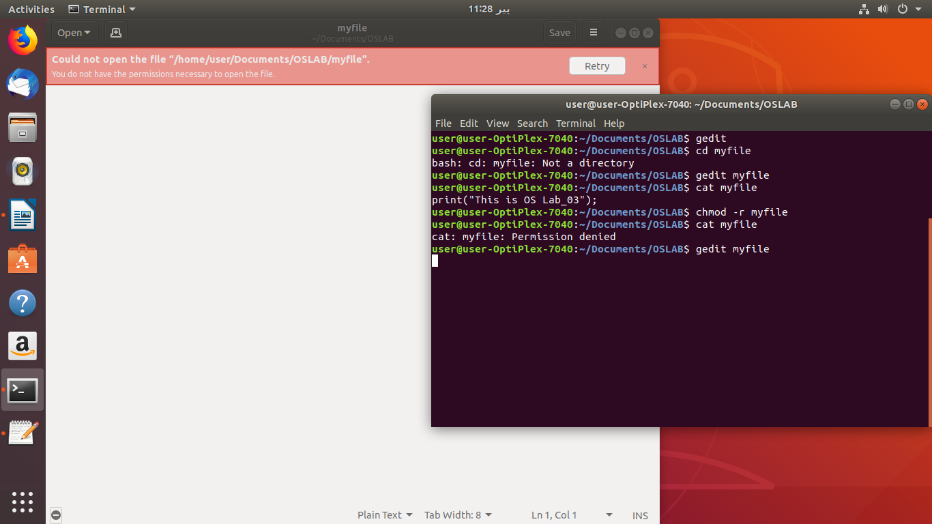

+R:
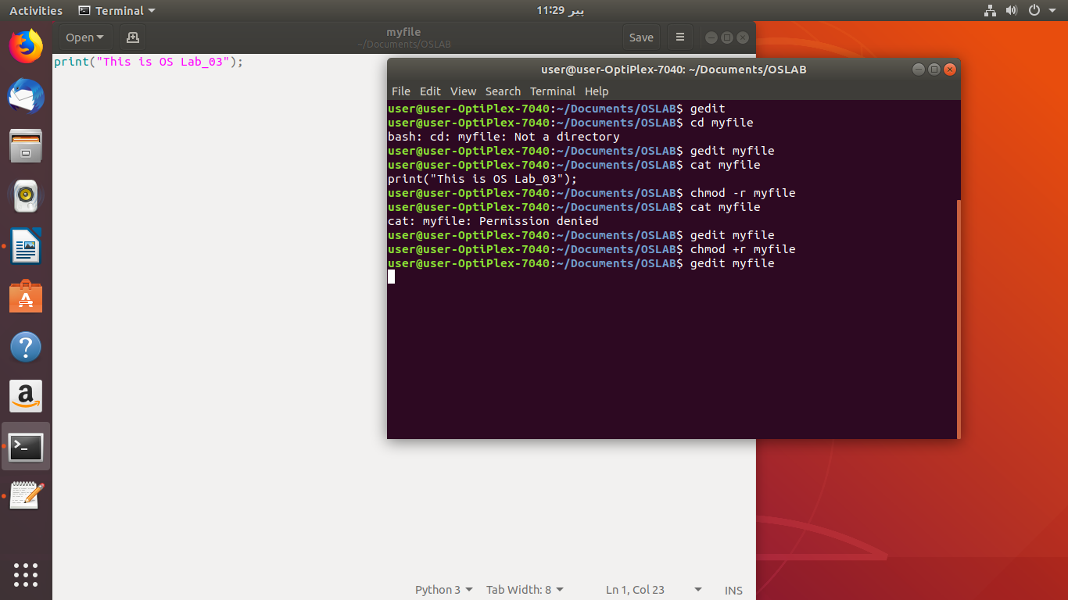
-W:
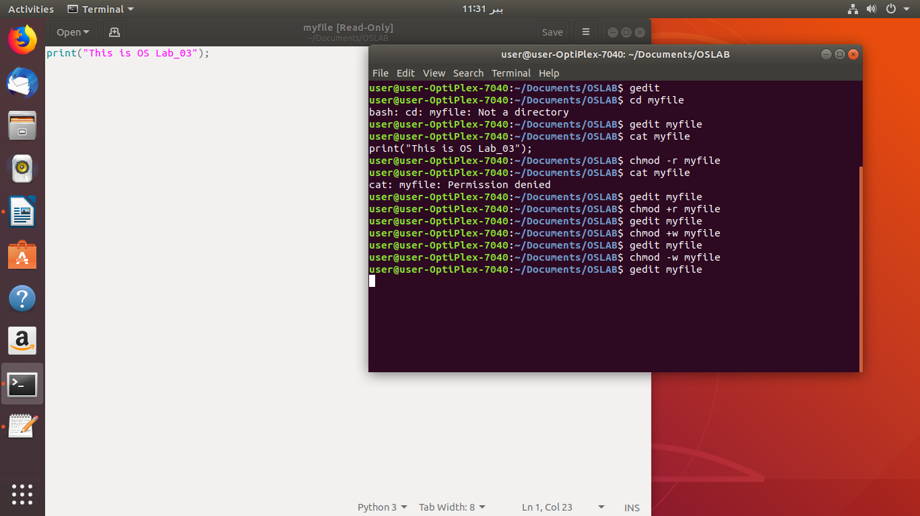
+W:
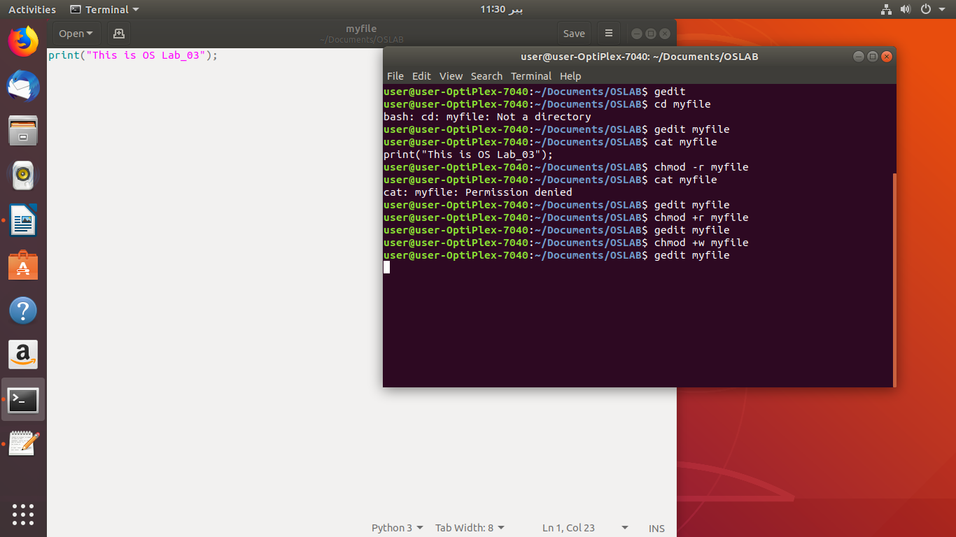
-X:
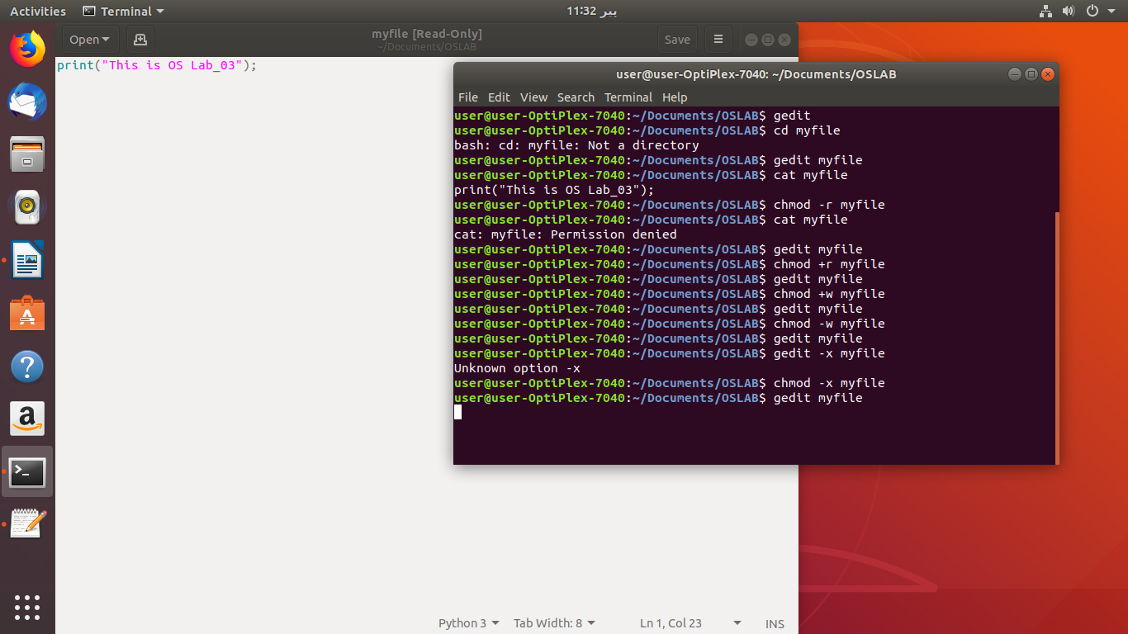
+X:
